**Who was Nannie Helen Burroughs and**

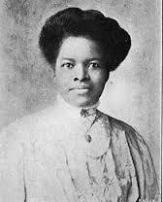 **Nannie Helen Burroughs 1879-1961**

**Why Should We Care?** Born on May 2, 1879 to freed slaves, Burroughs grew-up to become a religious and civil rights activist and pioneering educator. Fueled by her deep religious conviction as a member of the Nineteenth Street Baptist Church in Washington, DC, where

Reverend Dr. Walter H. Brooks (pastor 18821945) served as her mentor, confident and inspiration, she became a powerful force for women in the National Baptist Convention. With a startling address entitled, “How the Sisters are Hindered from Helping” at the 1900 convention in Richmond, Virginia, Burroughs began the fight to gain greater recognition for women in church decision-making.

Because of her unusual visibility at the convention, a man noted “Who’s that young girl? Why don’t she sit down? She’s always talking. She’s just an upstart.” Burroughs responded, “I might be an upstart, but I am just starting up.” True to her word, she spearheaded the establishment of the Woman’s Auxiliary to the Baptist Convention in 1901; was chosen the Auxiliary’s first secretary and served in that capacity until her election as president in 1948. She was selected keynote speaker at the aforementioned Baptist World Alliance Congress where The London Daily Express described her as “a woman of great

oratorical gifts.”

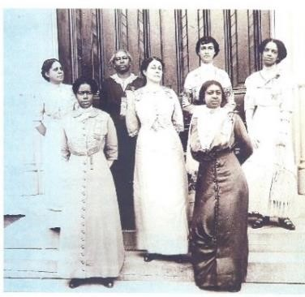In 1906, she introduced what was to be her most significant contribution to the Baptist Church, Woman’s (aka Women’s) Day. The purpose was to teach women to become public speakers and leaders in the community. The first Woman’s Day program was held in 1907 on the fourth Sunday in July.

Although Burroughs never confronted the ban on women in the pulpit, all other forms of exclusion from the church and society were fair game.

**Founding the School:** Disappointed that she was denied a teaching position (which she attributed to her dark skin), Burroughs declared that she would one day open a school for women and girls in Washington, DC. Despite many vocal critics and financial difficulties, her faith kept her moving toward her goal.

Finally, after 13 years of personal and financial

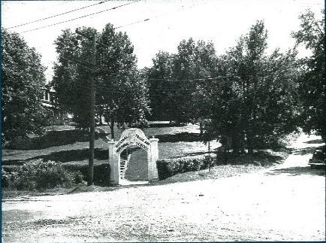struggles and moves from Washington to Philadelphia, to Louisville and back to Washington, her dream was realized. On October 17, 1909 the school held its opening ceremonies with Mary McLeod Bethune as guest speaker. Situated on 6 acres that Burroughs named “Holy Hill” in northeast Washington, the first class was comprised of 31 students from across the country as well as Africa, Haiti, Panama, and India. The curriculum sought to prepare young women to improve home life and remake their communities by stimulating positive character traits and a strong work ethic.

The school’s motto was “Bible, Bath and Broom” encompassing, as Burroughs later said, “clean lives, clean bodies, and clean homes… the race that excels in the use of these three instruments is the most highly civilized.” Burroughs knew early-on that African American women needed to be educated and hone the skills desired by the marketplace. While the school was based on Booker T. Washington’s “industrial education” it included facets of W.E.B. DuBois’ “liberal tradition.” In addition, because of her close association with Carter G. Woodson, the program of study emphasized black history.

**Civil Rights and Respect for All:** Although she fought vigorously for racial and gender equality, she also sought cooperation between the races. In 1896, at the age of 17, Burroughs joined in the founding of the National Association of Colored Women (NACW), which played a major role in social and political reforms during the first half of the 20th century.

After a 1934 speech to a Florida NACW chapter, a white woman rose to her feet and exclaimed:

*I do not deal in superlatives, but Miss Burroughs has given a matchless address. She is not only up-to-date in her understanding and analyses of great questions, but she is 50 years ahead of her time*.

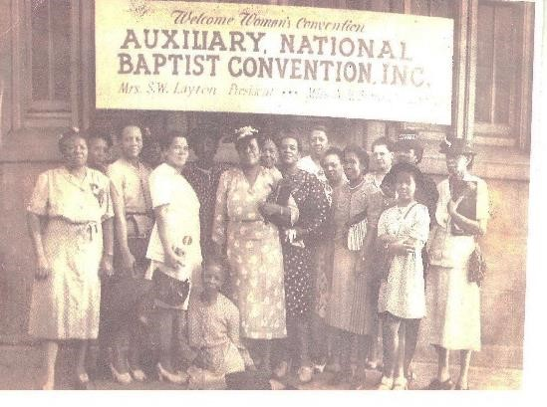It was also in 1934 that she joined an NAACP rally demanding that the Attorney General include lynching in the 1934 Crime Conference agenda. She thundered to the crowd: “There are enough Negroes in Washington tonight to make Pennsylvania Avenue tremble…”

Also, in the 1930s, Burroughs resumed publication of *The Worker*, a quarterly magazine which she started in 1912 to emphasize the need for foreign as well as domestic missionary work. As Burroughs views became more controversial, however, she lost the financial support of the male-dominated National Baptist Convention (NBC) and influential church women and *The Worker* ceased publication. Always a creative problem solver, Burroughs cooperated with Una Roberts Lawrence, study editor of the Southern Baptist Convention Women’s Missionary Society, to increase interracial cooperation among black and white women and, thereby, increase circulation and revenue.

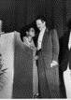For the rest of her adult life, Nannie Helen Burroughs stood on the frontlines across America demanding equal justice for all. Viewing voter participation as a right and obligation, Burroughs’ views on voting were expressed in a 1934 article, “…you vote for the man in whom you conscientiously believe without coercion, coin or compromise.” Many prominent leaders recognized her contributions.

In 1954, Thurgood Marshal said about her:

*All of us are forever indebted to you for the long hard fight you have made for our people. You will forever be an inspiration to all of us.*

A 1956 telegram from Dr. King and Rev. Abernathy invited her to speak at the one-year anniversary of the Montgomery Bus Boycott:

*As the first leader of Negro Women in America, it is imperative that you come to give hope to the thousands of women who are paying the price of sacrifice in our struggle.*

Dr. King spoke again about Burroughs after they appeared together in 1958:

*Your remarks after my address were magnificent. You said in a few words more than most people could say in hours. It is always a real inspiration to listen to you.*

Over time, Burroughs came to support more militant civil rights activities. At a September 1960 Woman’s Convention meeting, she said: *“Black people must decide that they are done with satisfied ignorance and second-class citizenship*.”

In December she stated:

*The day of the protest has come. It has come out of centuries of suffering but that the ‘weapons’ of black warfare must not be frustration and hate. Rather, African Americans must use education, improvement of home and family life, and Christian living to achieve their goals.*

**Her Legacy:** Nannie Helen Burroughs passed away on May 20, 1961; she was 82-years old. Her Home Going Service was held on May 25 at the 19th Street Baptist Church. It was a three-hour service, attended by 800 people including ninety-five ministers, of whom nine spoke from the pulpit. The eulogy was given by her dear friend Reverend Dr. Earl Harrison of Shiloh Baptist Church. She was laid to rest in Suitland, MD at Lincoln Memorial Cemetery. The Eulogy read:

She is the last of the pioneer women in higher education. She was a voice crying in the wilderness, strong and loud, for equality of women with men.

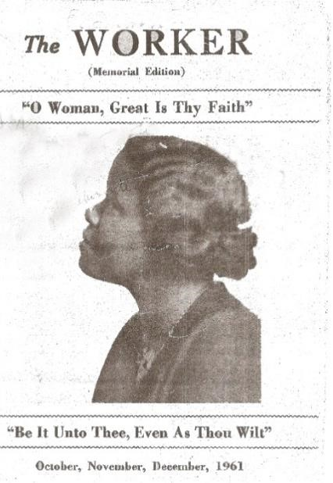 Nannie Helen Burroughs’ spirit of service and sacrifice energized her gifts as only faith and love can do. Her life’s dream of providing educational opportunities for and instilling Christian values in our children materialized on “Holy Hill” in Washington, DC. Today, Burroughs’ ideas are being revived and *The Worker* continues production on that same hill.